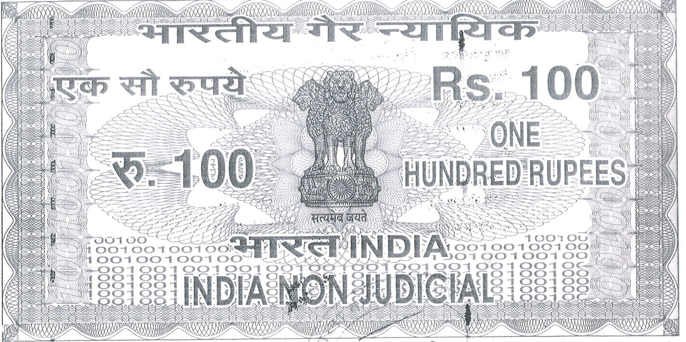

Before M/s J.K. Cement Works Kamla Tower, Kanpur Affidavit of Shri ___________________S/o ___________________________aged_________years, R/O______________________________

I deponent named above do hereby solemnly affirm and state as under:-

1. That deponent is the Proprietor/Partner of M/s__________________and such fully conversant with the facts disposed below.
2. That M/s _____________________________was appointed stockist for the sale of

Portland Cement Manufactured by M/s.J.K Cement Works

1. That M/s _____________________________is not interested in the business and trade of cement Manufactured by M/s JK. Cement Works and desired in discontinue the Stockistship.
2. That the original Appointment Letter for the Stockistship and the original Money Receipt towards Security Deposit issued by M/s JK Cement Works to M/s___________________

Has been lost /misplaced and are not traceable.

1. That the deponent under takes that any use of such documents will be sole responsibility of M/s _______________________and JK Cement Works will not be liable for any action for such utilization of the lost documents.
2. That the deponent further undertake that in the event of the Original Appointment letter and Original Money Receipt of the Security Deposit if found any time the same shall be submitted to M/s JK. Cement works being unutilised.

………………………………….

Deponent

Verification

I do hereby verify that the contents of Para 1 to 6 are true to my personal knowledge and nothing has been concealed and no parts of its false.

So Help May God.

Verified at _________________on this day _____________

..………………………………….

Deponent